Payment：

A.Testing Wallet:

QFPAY does not provide testing wallet to merchants, so please ask Chinese mainland colleague for help.

Alipay HK Wallet link:

<https://play.google.com/store/apps/details?id=hk.alipay.wallet&hl=zh-cn>

HK wallet only applicable offline quick pay right now.

If a customer uses a HK wallet to scan the Alipay QR code on a PC, it will shows like:

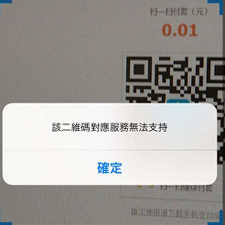

If a customer uses a HK wallet with WAP payment, it will shows like:

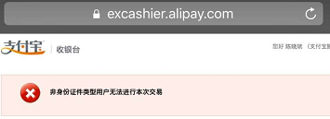

B.URL(Callback/Return)

They are set by QFPay staff, one appid can only have one pair of URL(Callback/Return).

Return URL:After success payment, it will redirect to that URL

Callback URL:After success payment, it will send notification to merchants’ back-end.(30s interval with 4 times)

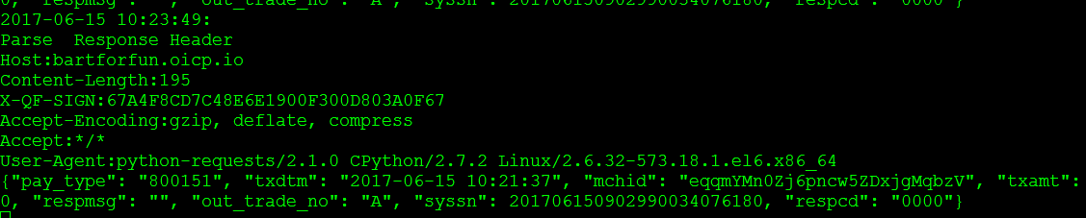

The above is the notification message.

C.Filter error:

When shows like below:

[respcd] => 1104

[respmsg] => filter error

It means this payment type is not available right now.

D.Refund：

A.What does 2999 means?

When invoke refund interface, sometimes, it will return like this:

{"orig_syssn":"201706090901990033885758","resperr":"交易失败，请联系客服(2999)","txdtm":"2017-06-09 19:16:36","txamt":"1","respmsg":"","out_trade_no":"qfpay_alipay999920170609191636","syssn":"201706090901990033885799","origssn":"201706090901990033885758","respcd":"2999","sysdtm":"2017-06-09 19:16:21"}

2999 means in pending state. After transaction finishes, the merchant backend should use query interface to check the transaction is OK.

E.product_name：

From Alipay APP：

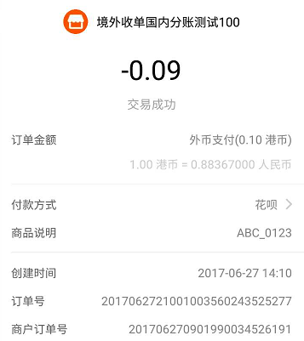

订单号：Alipay reference number

商户订单号：QFPay reference number

商品说明:product_name(Please use shop name+out_trade_no format for reference)

Wechat:

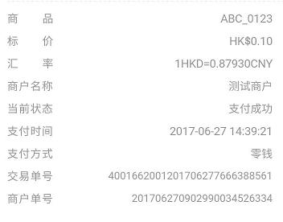

交易单号：Wechat reference number

商户单号：QFPay reference number

商品：product_name(Please use shop name+out_trade_no format for reference)

F.Can I use Alipay payment in Wechat？

You can not use Alipay in wechat, but if you jump out of Wechat, you can use Alipay.

G. After successful payment, what should I do?

The merchant can get asynchronous notification from QFPay, then the merchant back end should use query API to confirm the payment is successful.

H. What does 0000 means?

{

"respmsg": "",

"resperr": "",

"respcd": "0000",

"data": [

{

"pay_type": "800151",

"sysdtm": "2017-06-20 10:27:27",

"order_type": "payment",

"txcurrcd": "",

"txdtm": "2017-06-20 10:27:23",

"txamt": "10",

"out_trade_no": "TEST001",

"syssn": "201706200902990034258091",

"cancel": "0",

"respcd": "1145",

"errmsg": "交易错误，请联系钱方客服"

}

],

"page": 1,

"page_size": 10

}

0000 means successful. But there are also two meanings:

The first 0000,outside data field means it is a successful response.

The second 0000, inside data field means the request is successful.

I.How do I handle timeout?

The recommend time out time is 300s.

J.Difference between Wechat H5 and Alipay WAP:

Wechat H5 means Wechat official account payment. In the final step, invoke H5 to open the payment dialog.

Alipay WAP means Alipay payment in a mobile phone browser.

K.If the merchant does a refund, how long does it take?

It Depends. If refund to balance, it will in minutes. If refund to credit card, it may as long as 3 days.

L.If I use E-Shop plugin, can I use Oversea Qiantai?

It depends.If developer can develop the platform plugin,they can use QFPay API.

M.How do I define the currency?

What currency merchant apply for, which currency is available for use.

N.How about the exchange rate?

The exchange rate is set by Alipay and Wechat, it will update twice every day(10:00AM and 3:00PM). Merchant see local currency, customer pay RMB. QFPay do not do the settlement.

O. Sometimes, I can not get refund, what is the reason?

Because there are not enough sufficient amount.